**DSA0208- Open CV V.Divyadharshini**

**Assignment -2 192324031**

**1. Perform basic Image Handling and processing operations on the image.**

**• Read an image in python and Convert an Image to Grayscale**

import cv2

import matplotlib.pyplot as plt

image_path = r'C:\Users\divya\OneDrive\Pictures\Picture1.png' # Fixed path

image = cv2.imread(image_path

gray_image = cv2.cvtColor(image, cv2.COLOR_BGR2GRAY)

image_rgb = cv2.cvtColor(image, cv2.COLOR_BGR2RGB)

plt.figure(figsize=(10, 5))

plt.subplot(1, 2, 1)

plt.title("Original Image")

plt.imshow(image_rgb)

plt.axis("off")

plt.subplot(1, 2, 2)

plt.title("Grayscale Image")

plt.imshow(gray_image, cmap='gray')

plt.axis("off")

plt.tight_layout()

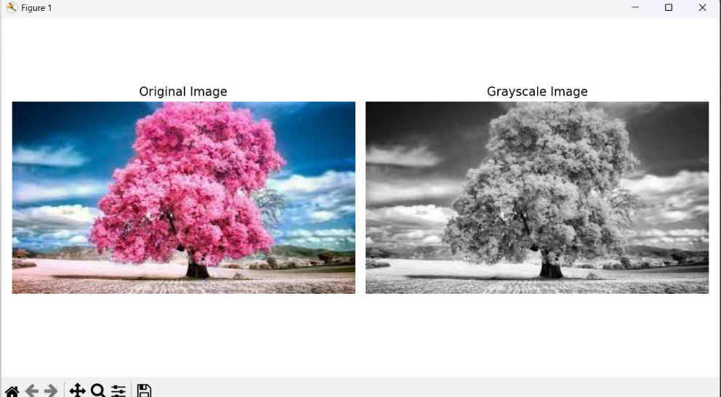plt.show()

**2) Perform basic Image Handling and processing operations on the image**

**• Read an image in python and Convert an Image to Blur using GaussianBlur.**

import cv2

import matplotlib.pyplot as plt

image_path = r'C:\Users\divya\OneDrive\Pictures\Picture2.jpg' # Replace with actual image path or name

image = cv2.imread(image_path)

image_rgb = cv2.cvtColor(image, cv2.COLOR_BGR2RGB)

blurred_image = cv2.GaussianBlur(image_rgb, (15, 15), 0)

plt.figure(figsize=(10, 5))

plt.subplot(1, 2, 1)

plt.title("Original Image")

plt.imshow(image_rgb)

plt.axis("off")

plt.subplot(1, 2, 2)

plt.title("Blurred Image (GaussianBlur)")

plt.imshow(blurred_image)

plt.axis("off")

plt.tight_layout()

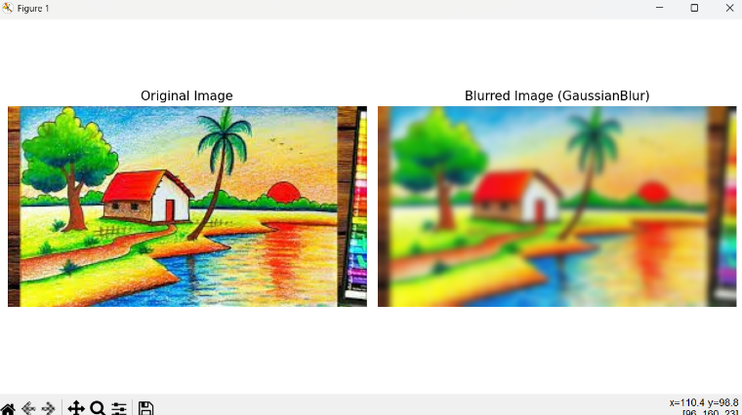plt.show()

**3. Perform basic Image Handling and processing operations on the image**

**• Read an image in python and Convert an Image to show outline using Canny function.**

import cv2

import matplotlib.pyplot as plt

image_path = r'C:\Users\divya\OneDrive\Pictures\Picture3.jpg' # Replace with actual file path or name

image = cv2.imread(image_path)

gray_image = cv2.cvtColor(image, cv2.COLOR_BGR2GRAY)

edges = cv2.Canny(gray_image, 100, 200) # You can adjust thresholds

image_rgb = cv2.cvtColor(image, cv2.COLOR_BGR2RGB)

plt.figure(figsize=(10, 5))

plt.subplot(1, 2, 1)

plt.title("Original Image")

plt.imshow(image_rgb)

plt.axis("off")

plt.subplot(1, 2, 2)

plt.title("Canny Edge Detection")

plt.imshow(edges, cmap='gray')

plt.axis("off")

plt.tight_layout()

plt.show()

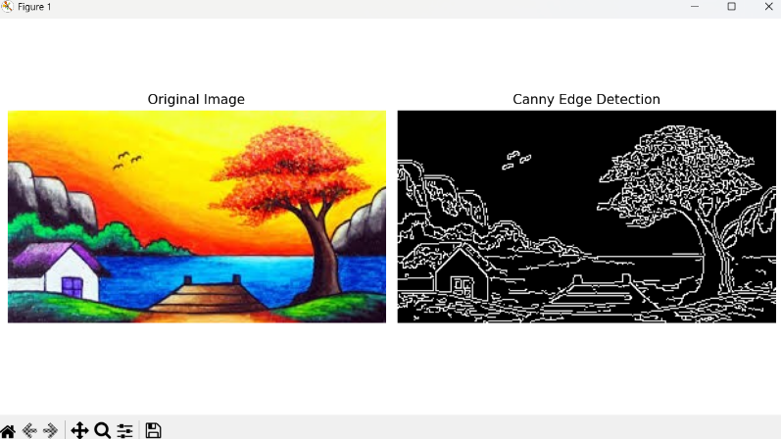

**4. Perform basic Image Handling and processing operations on the image**

**• Read an image in python and Dilate an Image using Dilate function.**

import cv2

import matplotlib.pyplot as plt

# Load the image

image_path = r'C:\Users\divya\OneDrive\Pictures\Picture4.jpg' # Replace with actual image path

image = cv2.imread(image_path)

gray_image = cv2.cvtColor(image, cv2.COLOR_BGR2GRAY)

_, thresh = cv2.threshold(gray_image, 120, 255, cv2.THRESH_BINARY)

kernel = cv2.getStructuringElement(cv2.MORPH_RECT, (5, 5))

dilated_image = cv2.dilate(thresh, kernel, iterations=1)

image_rgb = cv2.cvtColor(image, cv2.COLOR_BGR2RGB)

plt.figure(figsize=(10, 5))

plt.subplot(1, 2, 1)

plt.title("Original Image")

plt.imshow(image_rgb)

plt.axis("off"

plt.subplot(1, 2, 2)

plt.title("Dilated Image")

plt.imshow(dilated_image, cmap='gray')

plt.axis("off")

plt.tight_layout()

plt.show()

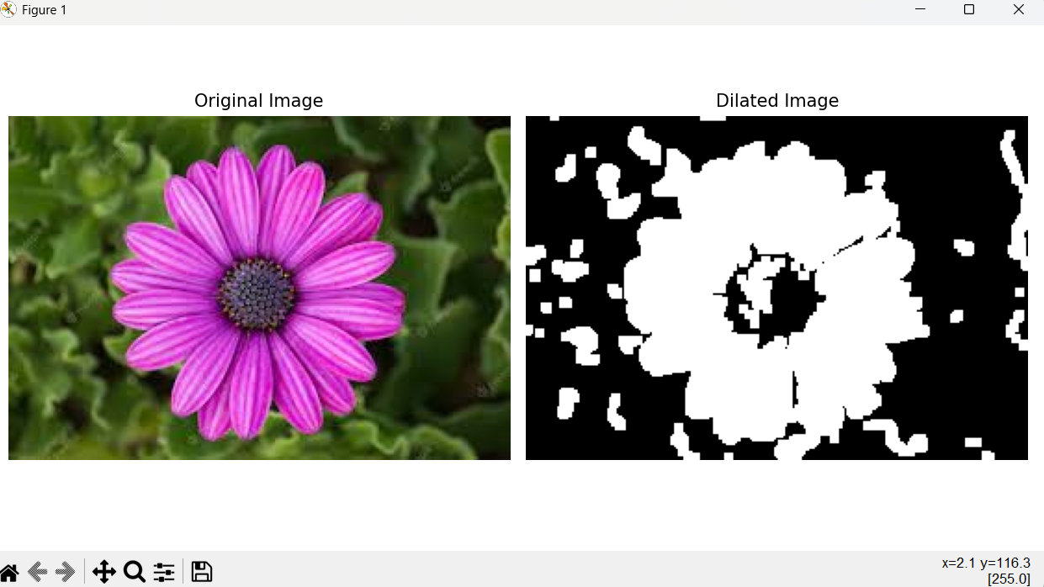

**5. Perform basic Image Handling and processing operations on the image**

**• Read an image in python and Erode an Image using erode function.**

import cv2

import matplotlib.pyplot as plt

image_path = r'C:\Users\divya\OneDrive\Pictures\Picture5.jpg' # Replace with your image file name

image = cv2.imread(image_path)

gray_image = cv2.cvtColor(image, cv2.COLOR_BGR2GRAY)

_, thresh = cv2.threshold(gray_image, 120, 255, cv2.THRESH_BINARY)

kernel = cv2.getStructuringElement(cv2.MORPH_RECT, (5, 5))

eroded_image = cv2.erode(thresh, kernel, iterations=1)

image_rgb = cv2.cvtColor(image, cv2.COLOR_BGR2RGB)

plt.figure(figsize=(10, 5))

plt.subplot(1, 2, 1)

plt.title("Original Image")

plt.imshow(image_rgb)

plt.axis("off")

plt.subplot(1, 2, 2)

plt.title("Eroded Image")

plt.imshow(eroded_image, cmap='gray')

plt.axis("off"

plt.tight_layout()

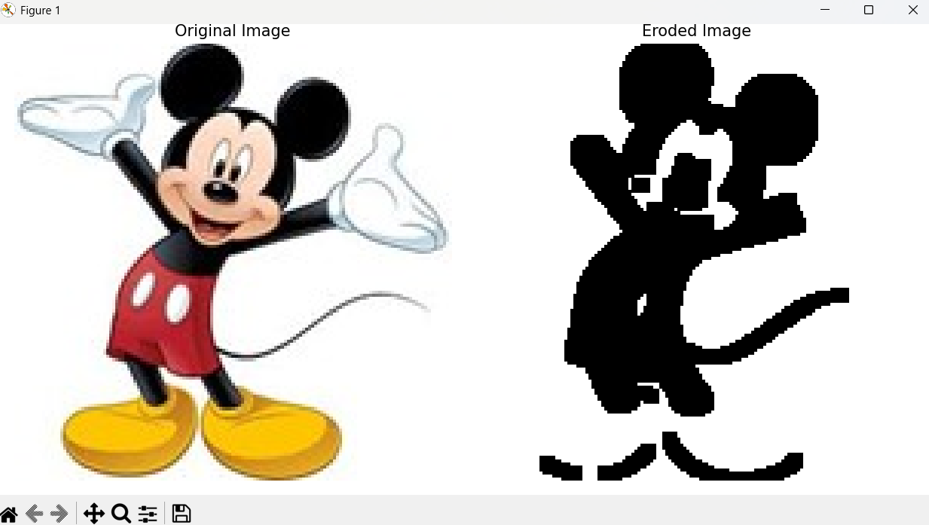plt.show()

**6. Perform basic video processing operations on the captured video**

**• Read captured video in python and display the video, in slow motion and in fast motion.**

**import cv2**

video_path = r'C:\Users\divya\OneDrive\Pictures\Camera Roll\exp_6cvv.mp4' # Replace with your video file path

cap = cv2.VideoCapture(video_path)

if not cap.isOpened():

print("Error: Cannot open video file.")

exit()

print("Choose playback mode:")

print("1 - Normal Speed")

print("2 - Slow Motion")

print("3 - Fast Motion")

mode = input("Enter 1, 2, or 3: ")

if mode == '1':

delay = 30 # Normal

elif mode == '2':

delay = 100 # Slow motion

elif mode == '3':

delay = 5 # Fast motion

else:

print("Invalid choice. Defaulting to normal speed.")

delay = 30

while cap.isOpened():

ret, frame = cap.read()

if not ret:

break

cv2.imshow('Video Playback', frame)

if cv2.waitKey(delay) & 0xFF == ord('q'):

break

cap.release()

cv2.destroyAllWindows()

**7. Capture video from web Camera and Display the video, in slow motion and in fast motion.**

import cv2

cap = cv2.VideoCapture(0) # 0 is the default camera

if not cap.isOpened():

print("Error: Cannot access the camera")

exit()

print("Choose playback speed:")

print("1 - Normal Speed")

print("2 - Slow Motion")

print("3 - Fast Motion")

mode = input("Enter 1, 2, or 3: ")

if mode == '1':

delay = 30 # Normal speed (~33 FPS)

elif mode == '2':

delay = 100 # Slow motion

elif mode == '3':

delay = 5 # Fast motion

else:

print("Invalid input. Defaulting to normal speed.")

delay = 30

print("Press 'q' to quit...")

while True:

ret, frame = cap.read()

if not ret:

break

cv2.imshow("Webcam Video", frame)

if cv2.waitKey(delay) & 0xFF == ord('q'):

break

cap.release()

cv2.destroyAllWindows()

**8. Scaling an image to its Bigger and Smaller sizes.**

import cv2

import matplotlib.pyplot as plt

image_path = r'C:\Users\divya\OneDrive\Pictures\Picture5.jpg' # Replace with your actual image path

image = cv2.imread(image_path)

image_rgb = cv2.cvtColor(image, cv2.COLOR_BGR2RGB)

bigger = cv2.resize(image_rgb, None, fx=2.0, fy=2.0, interpolation=cv2.INTER_LINEAR)

smaller = cv2.resize(image_rgb, None, fx=0.5, fy=0.5, interpolation=cv2.INTER_AREA)

plt.figure(figsize=(12, 6))

plt.subplot(1, 3, 1)

plt.title("Original Image")

plt.imshow(image_rgb)

plt.axis("off")

plt.subplot(1, 3, 2)

plt.title("Scaled Down (Smaller)")

plt.imshow(smaller)

plt.axis("off")

plt.subplot(1, 3, 3)

plt.title("Scaled Up (Bigger)")

plt.imshow(bigger)

plt.axis("off")

plt.tight_layout()

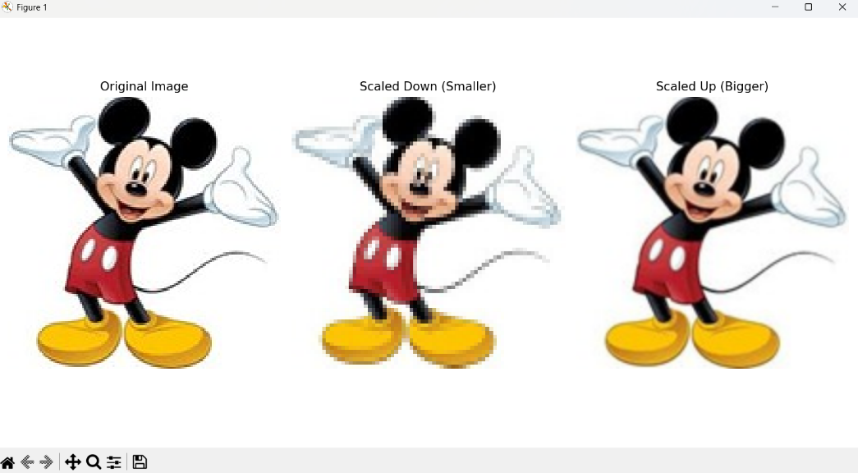plt.show()

**9. Perform Rotation of an image to clockwise and counter clockwise direction.**

import cv2

image = cv2.imread(r'C:\Users\divya\OneDrive\Pictures\Totoro.jpg') # Replace with your image path

(h, w) = image.shape[:2]

center = (w // 2, h // 2)

clockwise = cv2.rotate(image, cv2.ROTATE_90_CLOCKWISE)

counter_clockwise = cv2.rotate(image, cv2.ROTATE_90_COUNTERCLOCKWISE)

cv2.imshow("Original", image)

cv2.imshow("Clockwise Rotation", clockwise)

cv2.imshow("Counter-Clockwise Rotation", counter_clockwise)

cv2.waitKey(0)

cv2.destroyAllWindows()

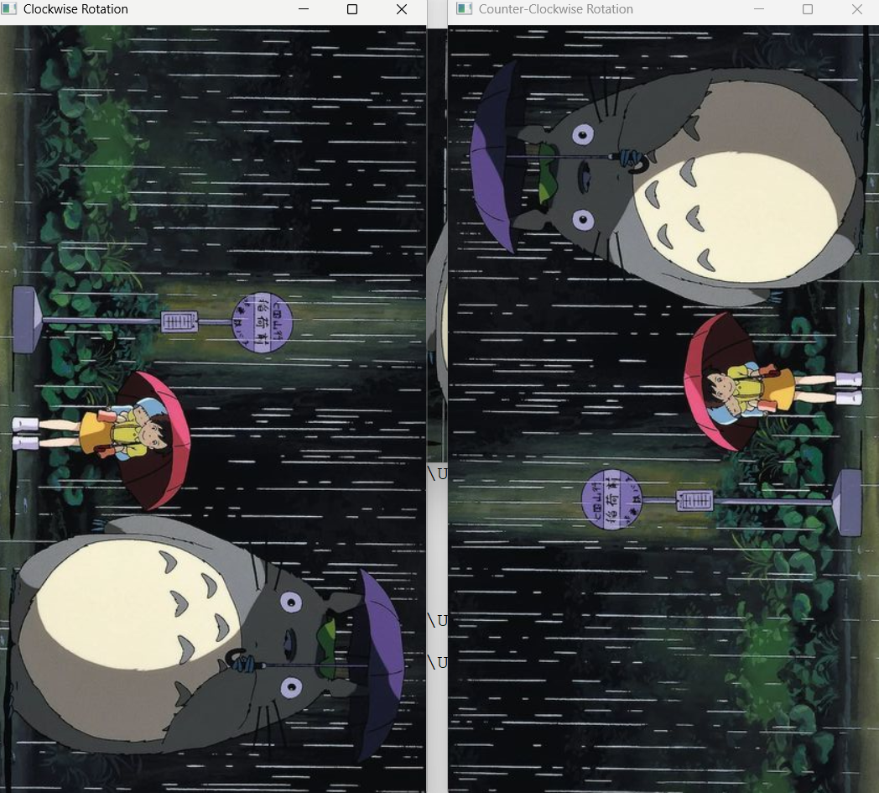

**10. Perform moving of an image from one place to another.**

import cv2

import numpy as np

image = cv2.imread(r'C:\Users\divya\OneDrive\Pictures\Totoro.jpg') # Replace with your image path

tx, ty = 100, 50 # tx = shift in x (right), ty = shift in y (down)

translation_matrix = np.float32([[1, 0, tx], [0, 1, ty]])

height, width = image.shape[:2]

moved_image = cv2.warpAffine(image, translation_matrix, (width, height))

cv2.imshow("Original Image", image)

cv2.imshow("Moved Image", moved_image)

cv2.waitKey(0)

cv2.destroyAllWindows()

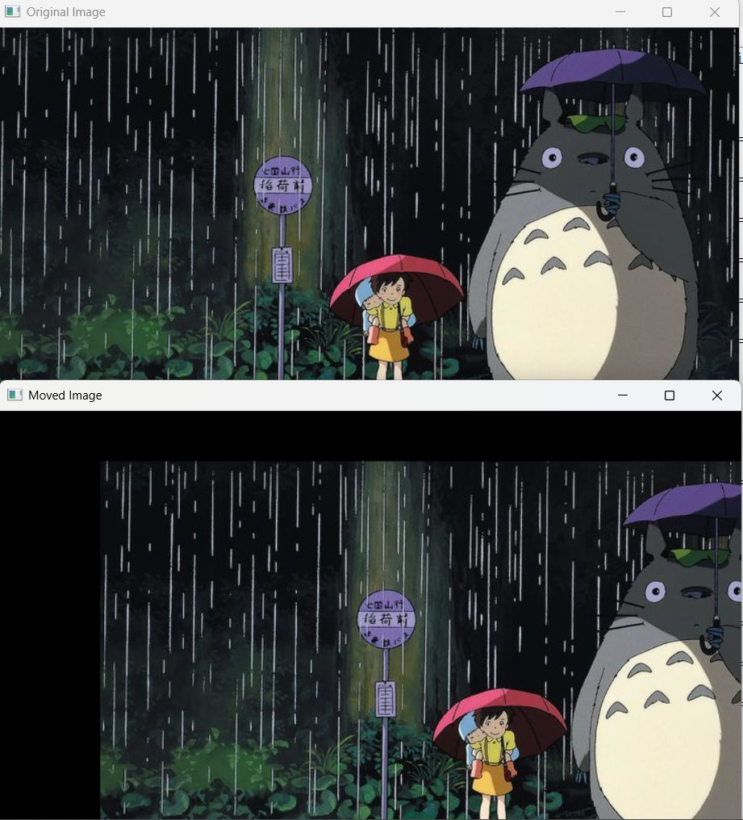

**11. Perform Affine Transformation on the image.**

import cv2

import numpy as np

image = cv2.imread(r'C:\Users\divya\OneDrive\Pictures\Totoro.jpg')

pts1 = np.float32([[50, 50], [200, 50], [50, 200]])

pts2 = np.float32([[10, 100], [200, 50], [100, 250]])

affine_matrix = cv2.getAffineTransform(pts1, pts2)

transformed_image = cv2.warpAffine(image, affine_matrix, (image.shape[1], image.shape[0]))

cv2.imshow("Original Image", image)

cv2.imshow("Affine Transformed Image", transformed_image)

cv2.waitKey(0)

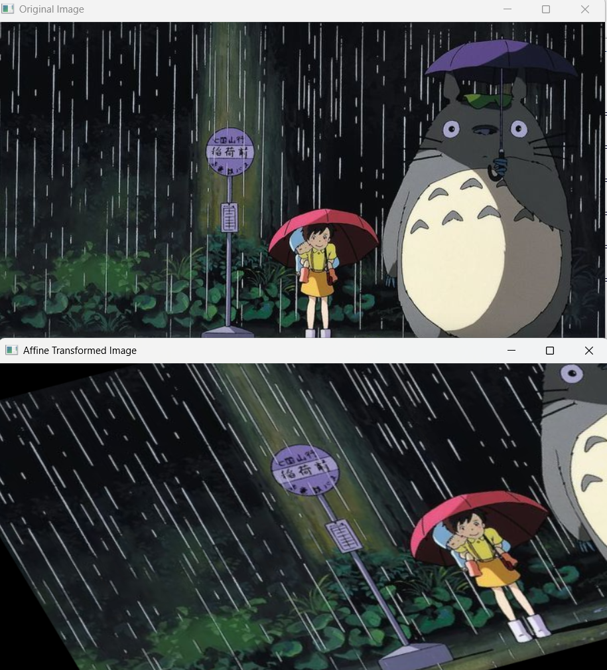cv2.destroyAllWindows()

**12. Perform Perspective Transformation on the image.**

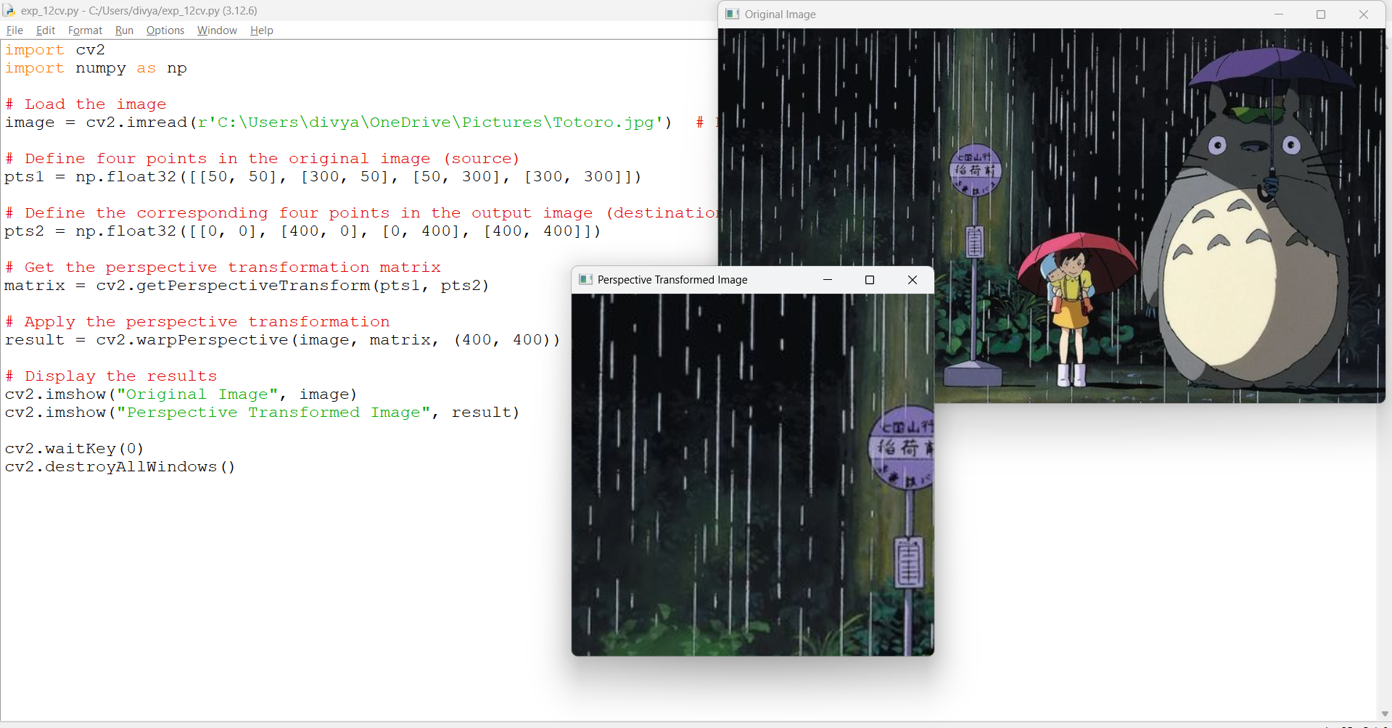

**13. Perform Perspective Transformation on the Video.**

import cv2

import numpy as np

cap = cv2.VideoCapture(r'C:\Users\divya\OneDrive\Pictures\Camera Roll\exp_6cvv.mp4') # Or use 0 for live webcam

src_pts = np.float32([[50, 50], [500, 50], [50, 400], [500, 400]])

dst_pts = np.float32([[0, 0], [400, 0], [0, 400], [400, 400]])

matrix = cv2.getPerspectiveTransform(src_pts, dst_pts)

while True:

ret, frame = cap.read()

if not ret:

break

warped = cv2.warpPerspective(frame, matrix, (400, 400))

cv2.imshow('Original Video', frame)

cv2.imshow('Perspective Transformed Video', warped)

if cv2.waitKey(1) & 0xFF == ord('q'):

break

cap.release()

cv2.destroyAllWindows()

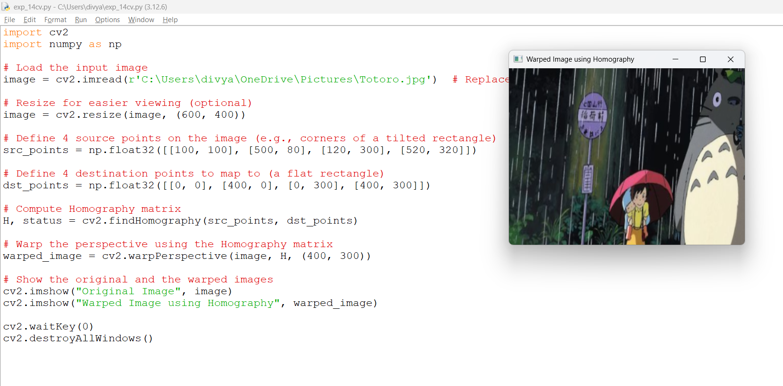**14. Perform transformation using Homography matrix.**

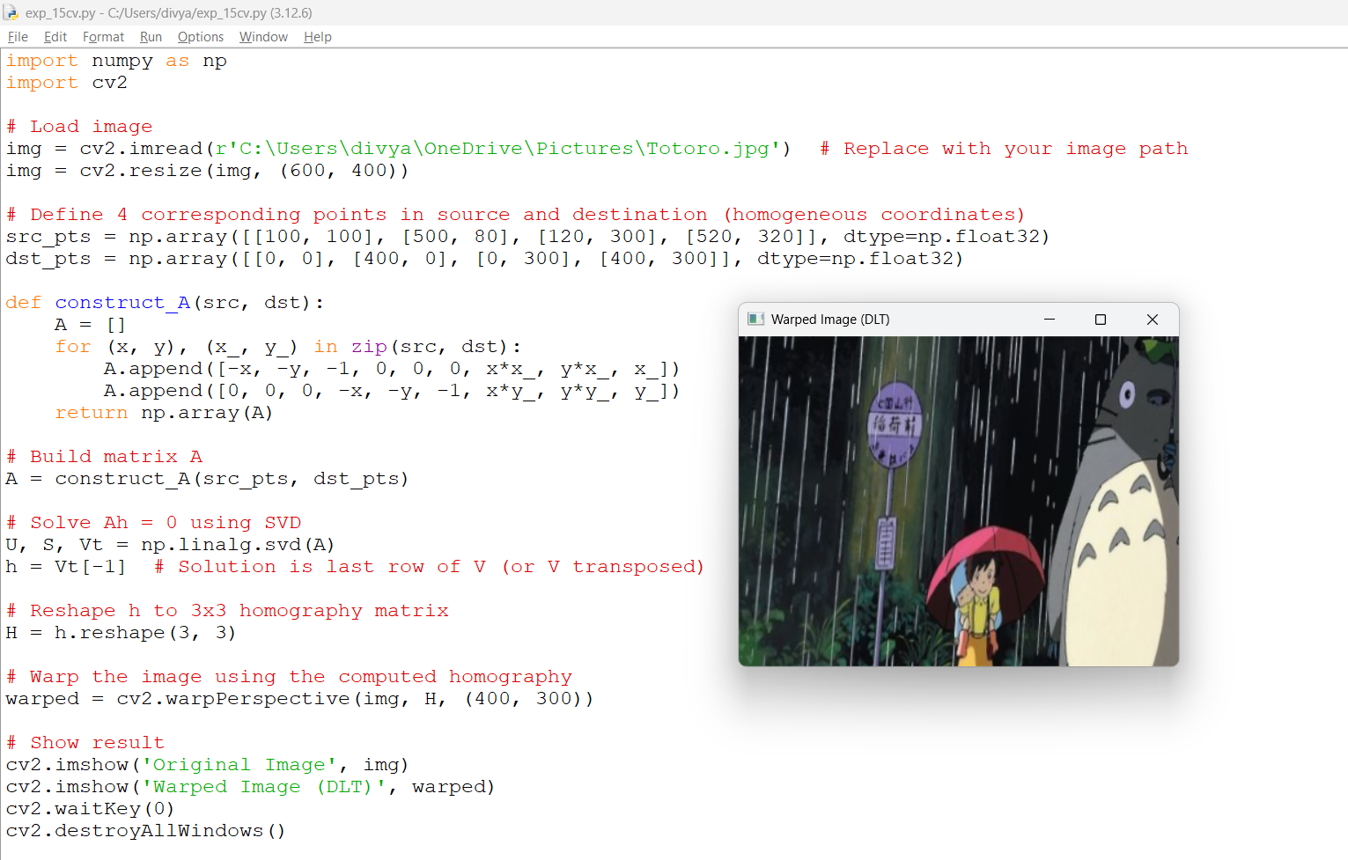**15. Perform transformation using Direct Linear Transformation.**

**16. Perform Edge detection using canny method**

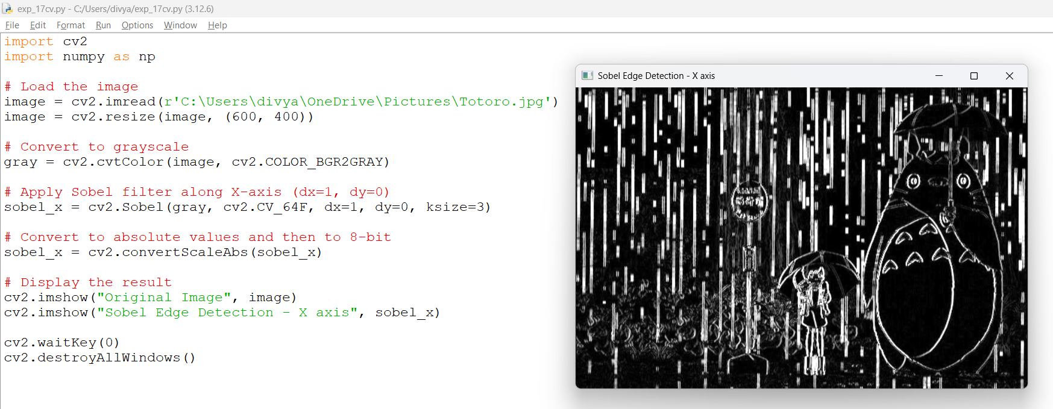**17. Perform Edge detection using Sobel Matrix along X axis**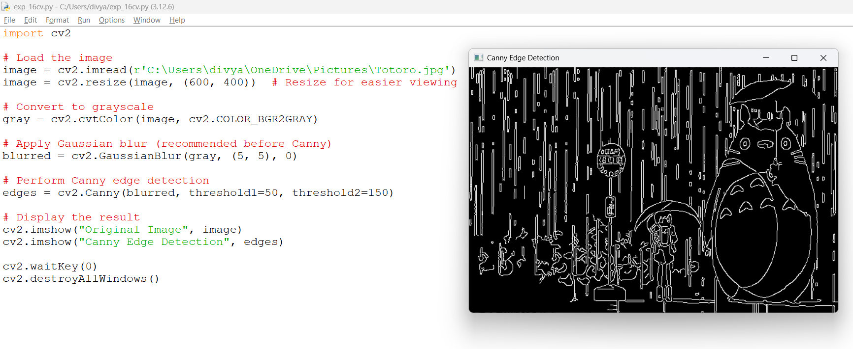

**18. Perform Edge detection using Sobel Matrix along Y axis**

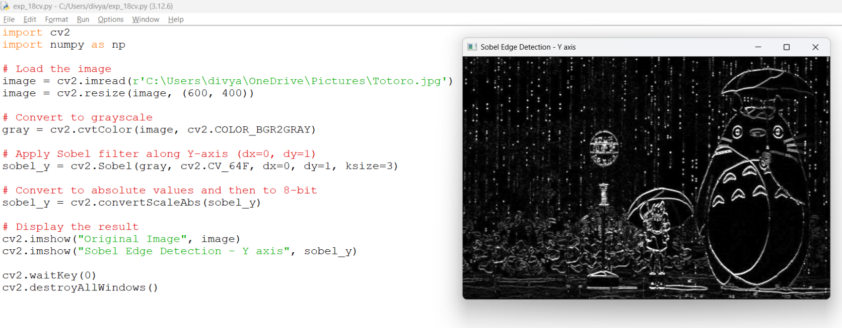

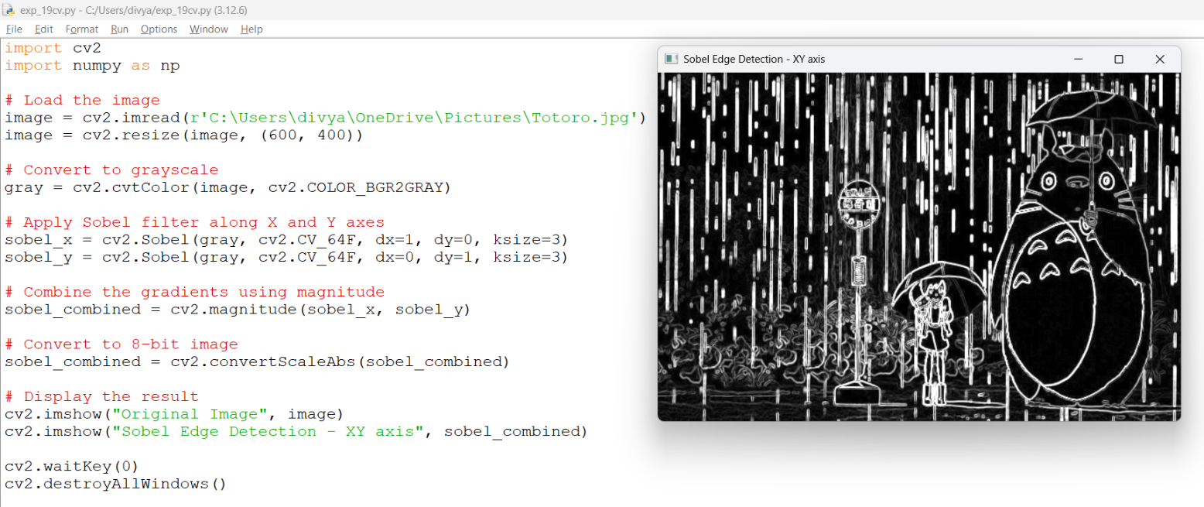**19. Perform Edge detection using Sobel Matrix along XY axis**

**20. Perform Sharpening of Image using Laplacian mask with negative center coefficient.**

import cv2

import numpy as np

img = cv2.imread('image6.png', cv2.IMREAD_GRAYSCALE)

if img is None:

    print("Error: Image not found.")

    exit()

laplacian_kernel = np.array([[0,  1, 0],

                             [1, -4, 1],

                             [0,  1, 0]])

laplacian = cv2.filter2D(img, cv2.CV_64F, laplacian_kernel)

sharpened = cv2.convertScaleAbs(img - laplacian)

cv2.imshow('Original Image', img)

cv2.imshow('Sharpened Image (Laplacian - Negative Center)', sharpened)

cv2.waitKey(0)

cv2.destroyAllWindows()

